Hackathon 3 - Day 5

Marketplace Technical Foundation Marketplace Technical Foundation - [Nike] By: Touqeer Ahmed

Roll Number: 306062

Billing Information:

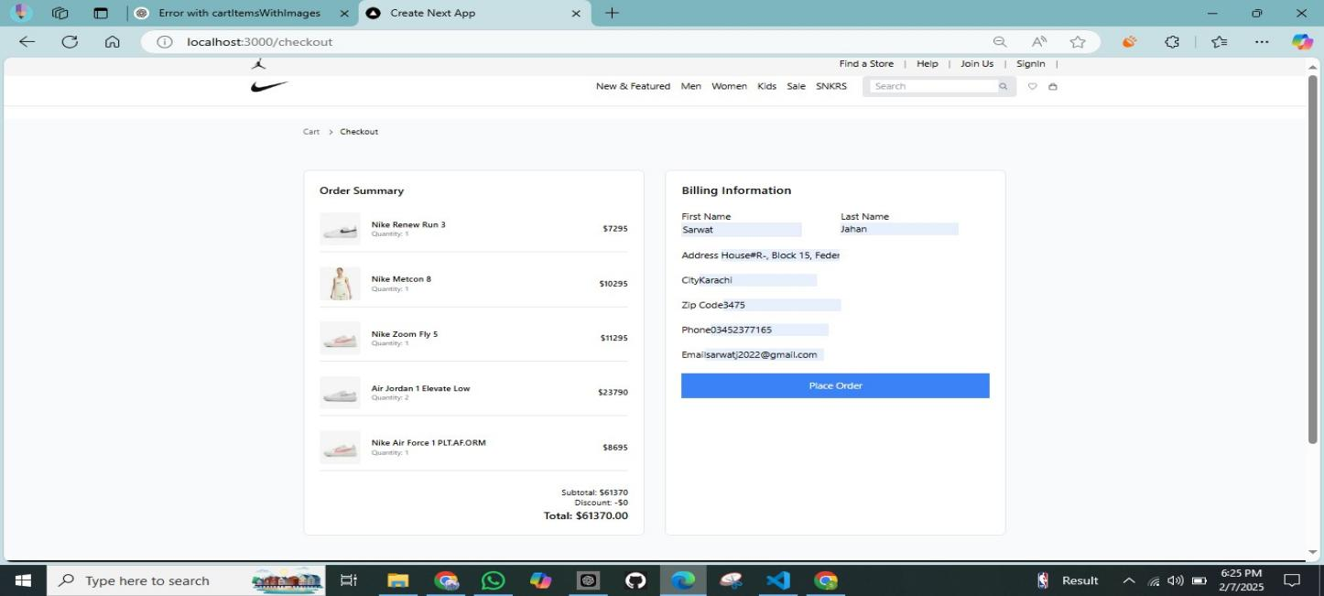

Add To Cart Functionality:

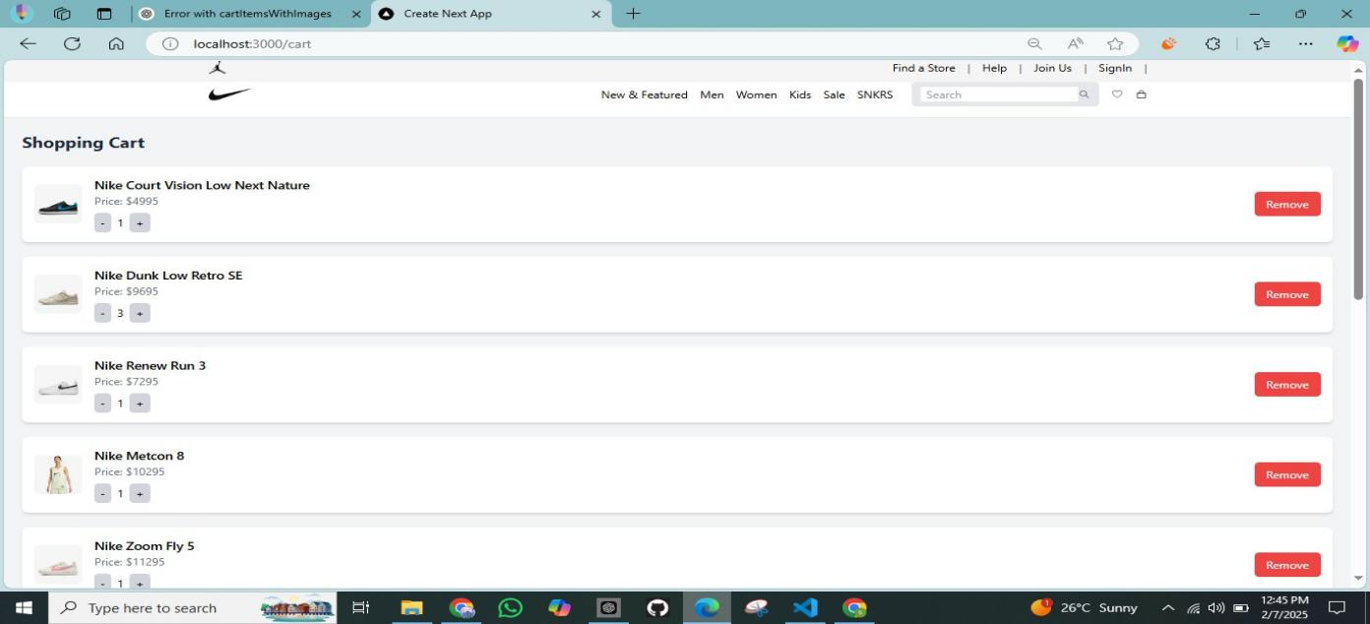

**Performance Monitor:**

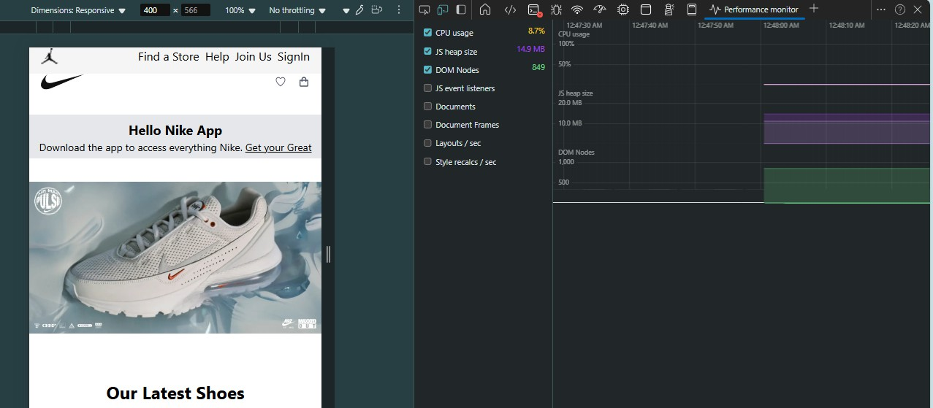

**Security :**

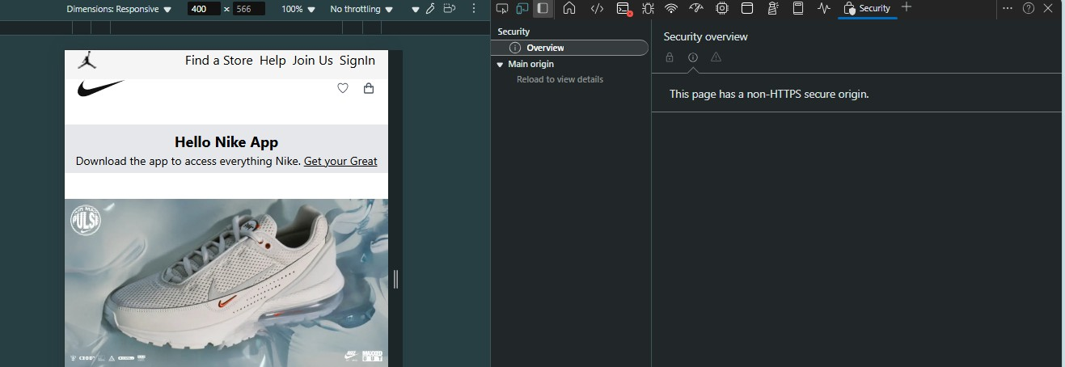

**Developer Resources:**

